CPU Management in Linux

**Task 1: Monitoring CPU Usage**

‘top’ :
- The top command shows a real-time view of running processes in linux and displays kernel-managed tasks.
- It also provides a system information summary that shows resource utilization,including CPU and memory usage.
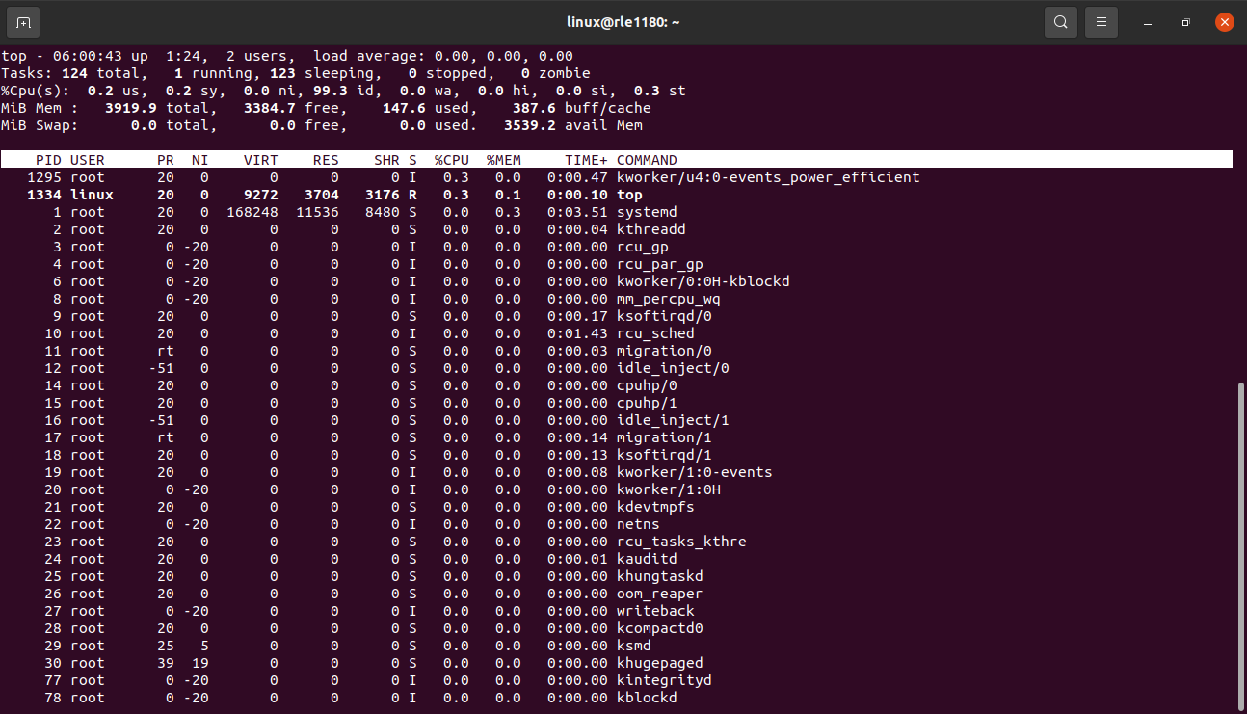
‘htop’:
- It is a command line utility that allows the user to interactively monitor the server’s processes in real time.
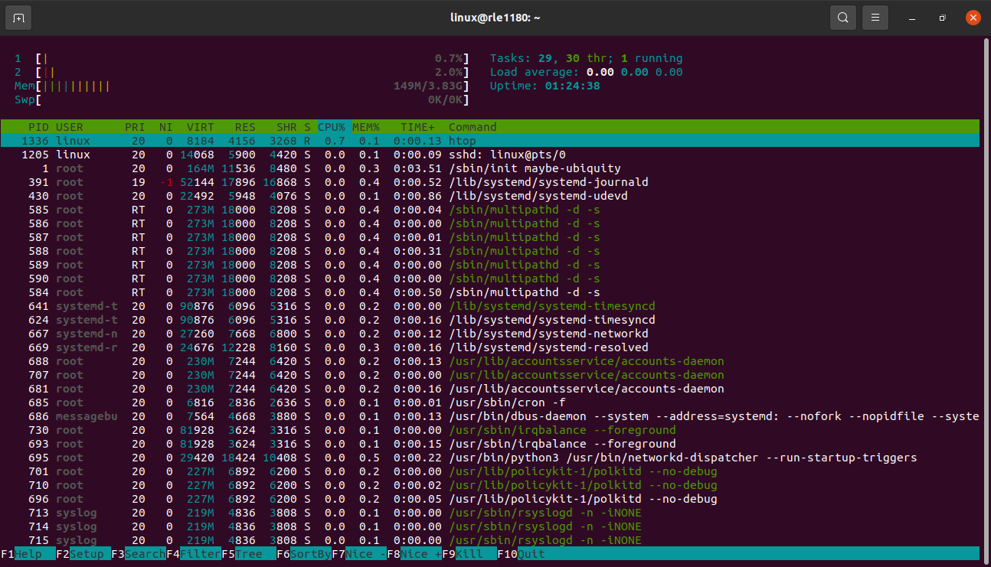

Mpstat -P ALL :
- The `mpstat -P ALL` command is used in Linux to display detailed processor (CPU) statistics, specifically per-processor statistics. It provides information about the CPU usage, performance, and other metrics for each available processor core on the system.
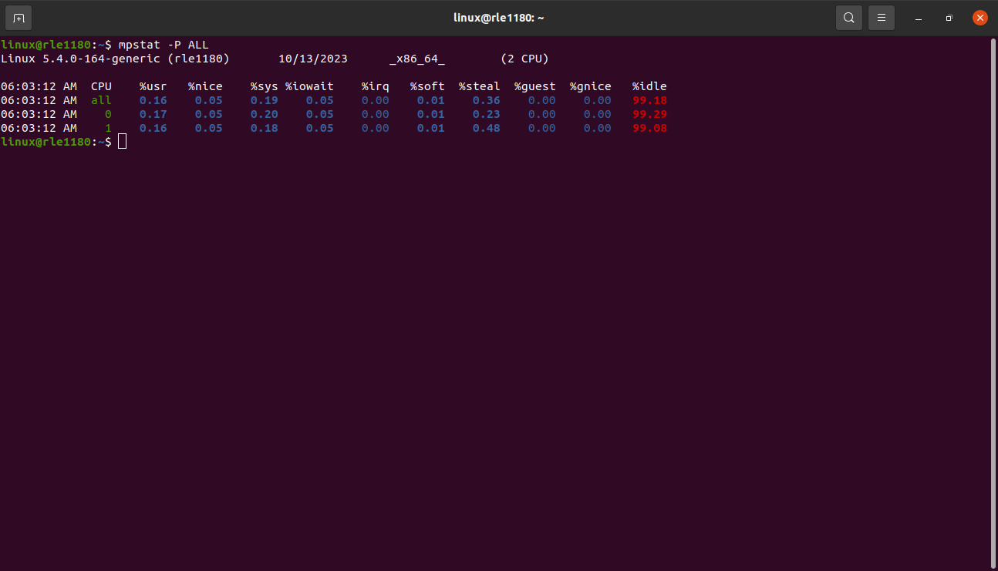
- `mpstat`: This is the command itself, which stands for "multiprocessor statistics." It's used for monitoring and reporting CPU usage and statistics.

- `-P ALL`: This option tells `mpstat` to display statistics for all available processors or CPU cores. The `-P` flag is followed by `ALL` to indicate that you want information for all processors. If you want to see statistics for a specific processor, you can replace `ALL` with the processor number (e.g., `mpstat -P 1` to get statistics for the first processor core).

**Task 2: Controlling CPU Affinity**

- In this task i used ‘ps aux’ command to list running processes and their pid.
- after that i choose a process linx and noted its pid.
- Then i run “taskset -cp 0 <pid>” to set affinity manually in terminal
- By using the top command verified afinity with and also using ‘taskset -p <pid>’ commands.
- To automate this process i wrote a script named ‘set_cpuaffinity.sh’ file
- To run this file i use “./set_cpu_affinity.sh <pid> <cpu no>” command.
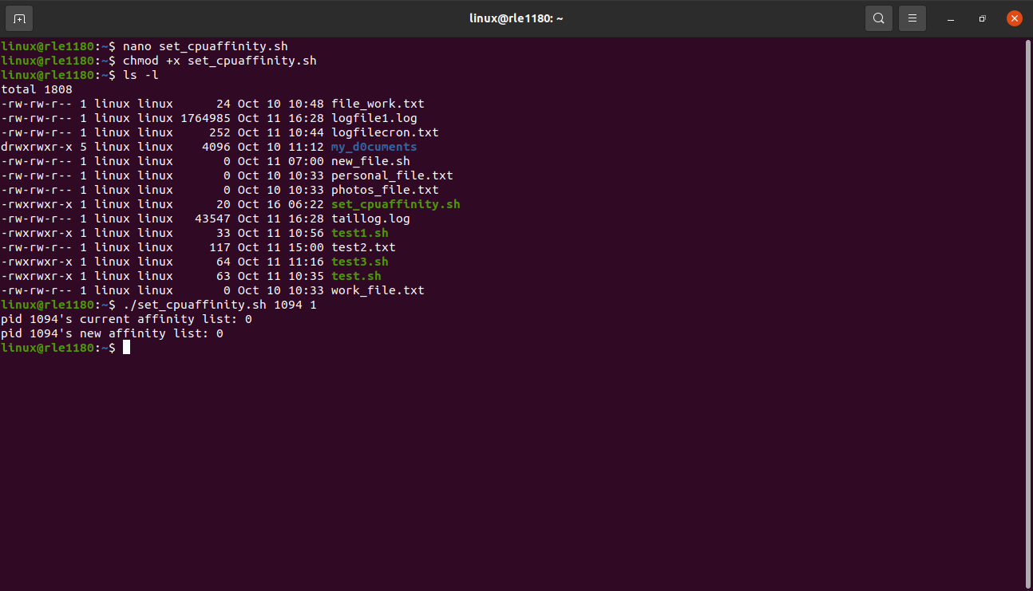

**Task 3: CPU Load Balancing**
- In this task at first i run `cat /proc/cpuinfo` this command will show all your cpu information.
- To increase cpu performance i used stress tool. This utility is used to stress all availble cpu. I used ‘stress –cpu 4’
- After this stress command i opened another terminal there i monitored my cpu utilization increases and it becomes 100%.
- I notice that the CPU load is spread across multiple cores, and as the load changes or tasks complete, the distribution of tasks may change as well.

**Task 4: Creating a CPU Monitoring Script**

- create a shell script file named cpu_monitor.sh .
Ex:
#!/bin/bash

  - # Output file to log CPU usage
  - log_file="cpu_usage.log"

  - # Function to get current CPU usage
  - get_cpu_usage() {
  - top -b -n 1 | grep '%Cpu' | awk '{print $2}'
  - }

  - # Main loop to log CPU usage every 10 seconds
  - while true; do
  - cpu_usage=$(get_cpu_usage)
  - timestamp=$(date +"%Y-%m-%d %H:%M:%S")
  - echo "$timestamp CPU Usage: $cpu_usage%" >> "$log_file"
  - sleep 10
  - done

- After that run a script using ‘./cpu_monitor.sh &’
- to see the output use the command “ tail -f cpu_usage.log”.
- To kill the above script use the command “pkill -f cpu_monitor.sh”.
